PROJECT

PIR motion sensor alarm using Arduino

Here, we are using a PIR motion sensor. This motion sensor consists of a fresnel lens, an infrared detector, and supporting detection circuitry. The lens on the sensor focuses any infrared radiation present around it toward the infrared detector. Our bodies generate infrared heat, and this heat is detected by the motion sensor. The sensor outputs a 5V signal for a period of one minute as soon as it detects the presence of a person. It offers a tentative range of detection of about 6–7m and is highly sensitive.

Circuit and Working

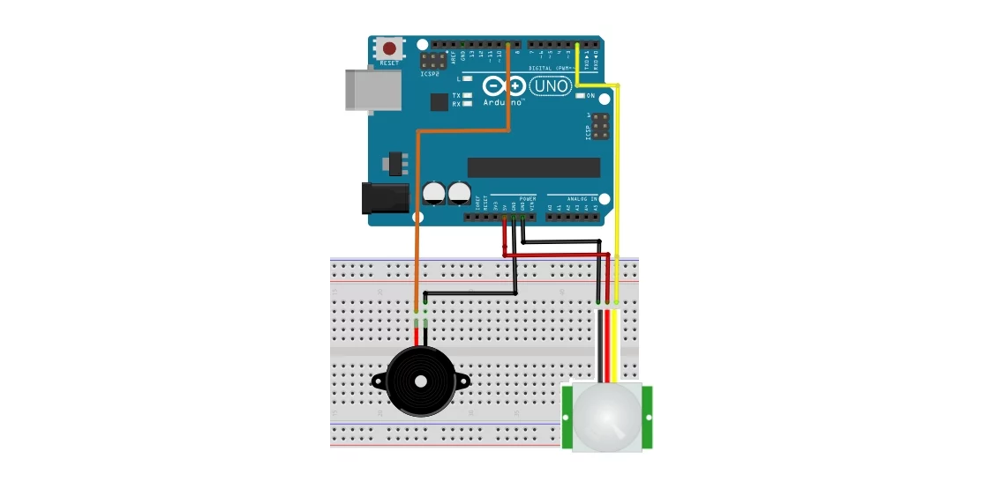

PIN CONNECTIONS

The connections required to interface the Arduino motion sensor and the piezo buzzer are very simple. Connect the motion sensor to your Arduino as per the following connection diagram. Connect the VCC and GND on the sensor to the Arduino's 5V and GND pins. Next, connect the output signal pin on the motion sensor to the Arduino's digital pin 2 (interrupt pin 0).

After hooking up the Arduino motion sensor, we have to connect the piezo buzzer to this system. To do this, connect the negative terminal of the buzzer (black wire) to the Arduino's GND pin and the positive terminal of the buzzer (red wire) to the Arduino's digital pin 9.

WORKING

When the PIR motion sensor detects a person, it outputs a 5V signal to the Arduino and triggers an interrupt. We define what the Arduino should do as it detects an intruder. Here, we are creating an alarm sound through a piezo buzzer. When the sensor detects an intruder, it triggers an alarm sound through the buzzer.

The piezo buzzer is activated through the Arduino using PWM (pulse width modulation) signals. The source code at the end of this tutorial will show you how to do this.

CODE

int speakerOut = 9;

byte names[] = {'c', 'd', 'e', 'f', 'g', 'a', 'b', 'C'};

int tones[] = {1915, 1700, 1519, 1432, 1275, 1136, 1014, 956};

byte melody[] = "2d2a1f2c2d2a2d2c2f2d2a2c2d2a1f2c2d2a2a2g2p8p8p8p";

int count = 0;

int count2 = 0;

int count3 = 0;

int MAX_COUNT = 24;

int statePin = LOW;

void siren();

volatile byte intruder;

void setup()

{

Serial.begin(115200);

attachInterrupt(0, intruder_detect, RISING);//Initialize the intterrupt pin for the motion sensor (Arduino digital pin 2)

intruder = 0;

}

void loop()

{

}

void intruder_detect()//This function is called whenever an intruder is detected by the arduino

{

intruder++;

Serial.println("Intruder detected");

for(int i=0; i<3; i++)//Play the alarm three times

siren();

}

void siren()//This function will make the alarm sound using the piezo buzzer

{

for (count = 0; count < MAX_COUNT; count++) {

for (count3 = 0; count3 <= (melody[count*2] - 48) * 30; count3++) {

for (count2=0;count2<8;count2++) {

if (names[count2] == melody[count*2 + 1]) {

analogWrite(speakerOut,1023);

delayMicroseconds(tones[count2]);

analogWrite(speakerOut, 0);

delayMicroseconds(tones[count2]);

}

if (melody[count*2 + 1] == 'p') {

// make a pause of a certain size

analogWrite(speakerOut, 0);

delayMicroseconds(100);

}

}

}

}

}

